基隆市成功國中康軒版英語科第六冊補考題庫

一、字彙選擇

1 ( A ) I like to read _____ on the newspaper. 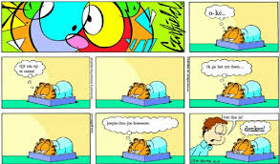(A) strips (B) odor (C) shower (D) memory

2.( B ) I want to put the flowers in the _______. 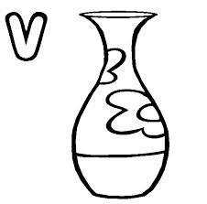 (A) chapter (B) vase (C) study (D) tense

3.( D ) My little sister is watching ______ on TV.  (A) village (B) experience (C) shock (D) cartoons

4.( C ) We have to take the ______ to the tenth floor. 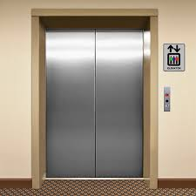 (A) accident (B) temperature (C) elevator (D) finding

5.( A ) Can I borrow this ______ from you? Sure. (A) magazine (B) memory (C) business (D) function

6.( C ) My teacher wrote something on my ______.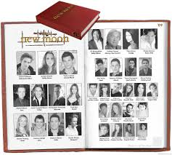 (A) beginning (B) fight (C) yearbook (D) host

7.( B ) I have ten _______ books. (A) jam (B) grammar (C) scientist (D) block

8.( A ) My brother will go to the _______ next week. 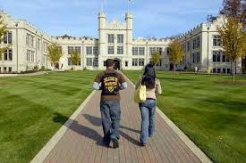 (A) college (B) cough (C) author (D) freedom

9.( D ) Will there be a ______ between the USA and North Korea(北韓)? (A) workbook (B) copy (C) turn (D) war

10.( A ) I like to visit a small ______ on holidays. (A) village (B) bestseller (C) product (D) temperature

二、單字配對

**(A) publish (B) explain (C) wild (D) riddle (E) lab (F) odor (G) slender (H) amazing (I) freedom (J) invent (K) tip (L) rough (M) perfect (N) study**

1. 解釋 B 2. 發明 J 3. 野生的 C 4. 謎語 D

5. 秘訣 K 6. 氣味 F 7. 實驗室 E 8. 苗條的 G

9. 令人驚奇的 H 10. 自由 I 11. 艱難的 L 12 研究 N

13. 出版 A 14完美M

三、選出正確片語

**(A) have a heart (B) keep in touch (C) keep a secret (D) call for help ( E) do online shopping (F) call in (G) pass away (H) take off your shoes (I) put one your coat (J) call off**

1. 取消 J 2. 發慈悲 A 3. 求救 D

4. 保守秘密 C 5. 去世 G 6 脫掉你的鞋子 H

7. 保持聯絡 B 8. 網路購物E 9. 穿上外套 I

10. 叩應(打電話至節目) F

四、選出正確圖片

|  |  |  |
| --- | --- | --- |
| A. 「accident」的圖片搜尋結果 | B.「temperature」的圖片搜尋結果 | C.「scientist」的圖片搜尋結果 |
| D. 「workbook」的圖片搜尋結果 | E. 「shower」的圖片搜尋結果 | F. 「host」的圖片搜尋結果 |

1.( A ) I saw a car accident on the way home.

2.( E ) Jimmy takes a shower every morning.

3.( F ) Mr. Lin is the host of my favorite show.

4.( C )Eddie wants to be a scientist in the future.

5.( B ) The weather is hot. The temperature is at 38 degrees.

6.( D ) Do you see my workbook? I need to do my homework now but I can’t find it.